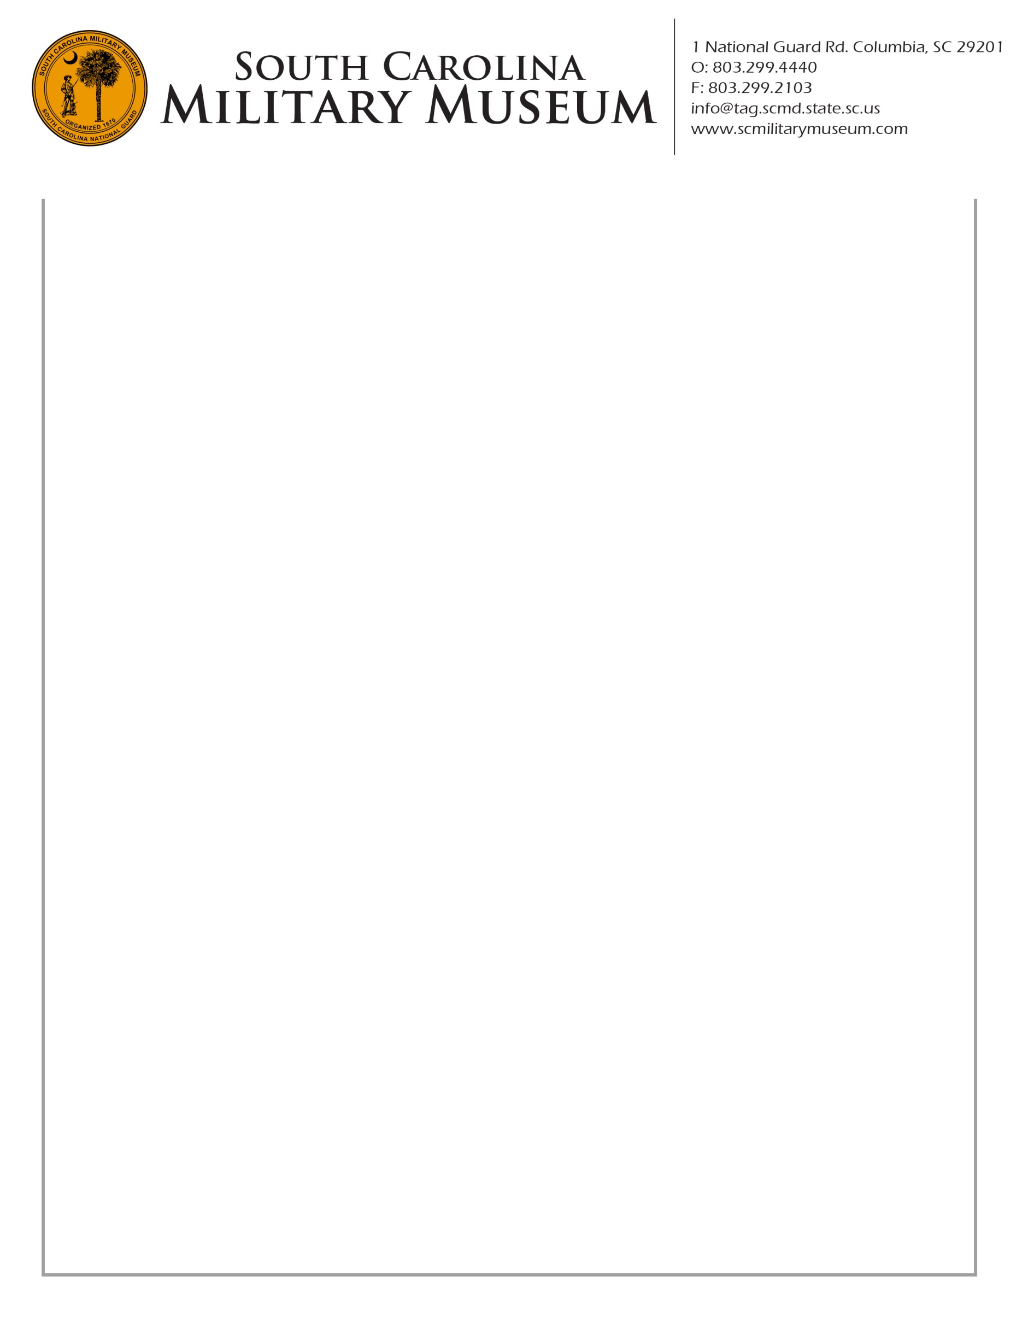

21 April 2015

Dear Post Commander:

The South Carolina Military Museum is considering holding a ceremony in October of 2015 to present the South Korean “Ambassador for Peace Medal” to those Korean War veterans who have not yet received one. Although October is several months away, time is of the essence due to a lengthy application process.

In order to make this process as easy as possible, the Museum is trying to collect individual service records – and any other relevant data – so it may send the applications *en masse* and on behalf of each Korean War veteran. Identifying those veterans who wish to receive the Peace Medal is therefore the first step.

This is precisely where the Museum needs your help. Please contact Korean War veterans in your Post and inquire whether they have received the Peace Medal and, if not, whether they wish to receive said Medal. Then forward us their names and contact numbers, **no later than 1 June 2015**, so my staff can begin putting together application packets.

If you have any questions, please contact me at your earliest convenience. Also note the Museum will support any Korean War veteran wishing to receive the Peace Medal, regardless of interest level in holding a ceremony thereto. Thanks in advance for your assistance.

Sincerely,

C:\Users\SCJeffcoat\Pictures\Buddy Signature.jpg

Ewell G. Sturgis

Director / Curator

SC Military Museum

1 National Guard Road

Columbia, SC 29201

803-299-4440

sturgiseg@tag.scmd.state.sc.us